***BE LAB ASSIGNMENT # 02***

***NAME: SHAHMEER KHAN.***

***CLASS ID: 106293.***

***STUDENT ID: 12113.***

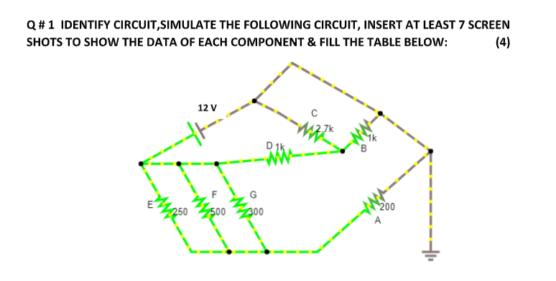

***Series-Parallel Circuit***

***Screenshots:***

1. Current, Voltage across Resistor A:

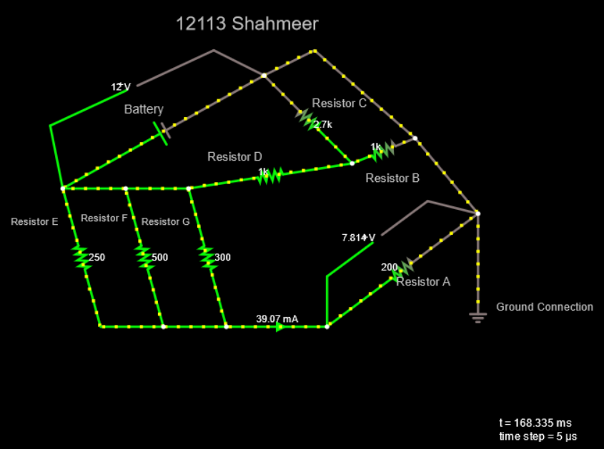

* ***It’s Link:***

<https://tinyurl.com/ydppxo3z>

1. Current, Voltage across Resistor B:

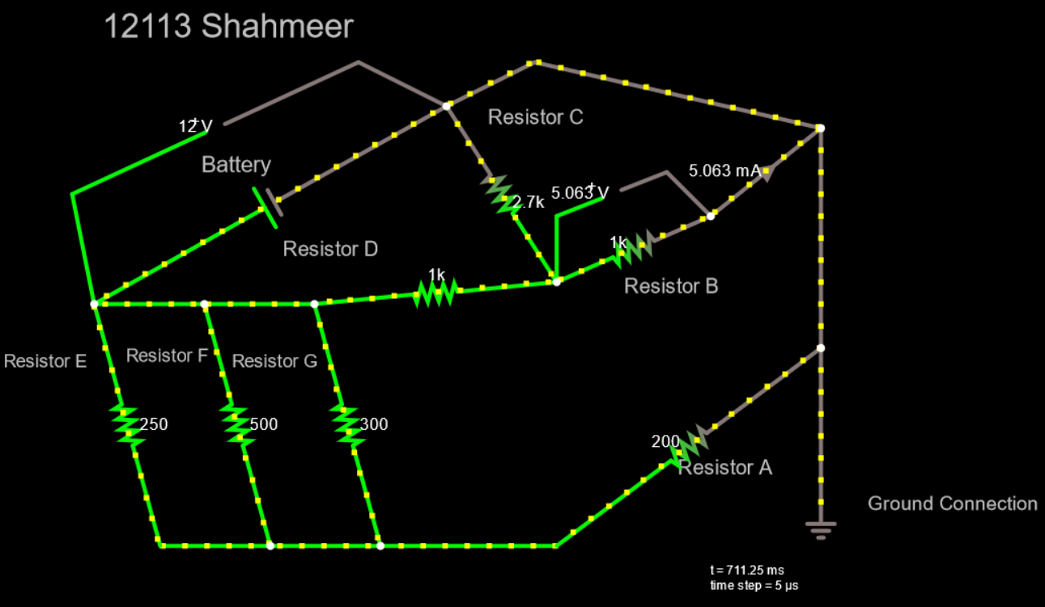

* ***It’s Link:***

<https://tinyurl.com/yh5blr2p>

1. Current, Voltage across Resistor C:

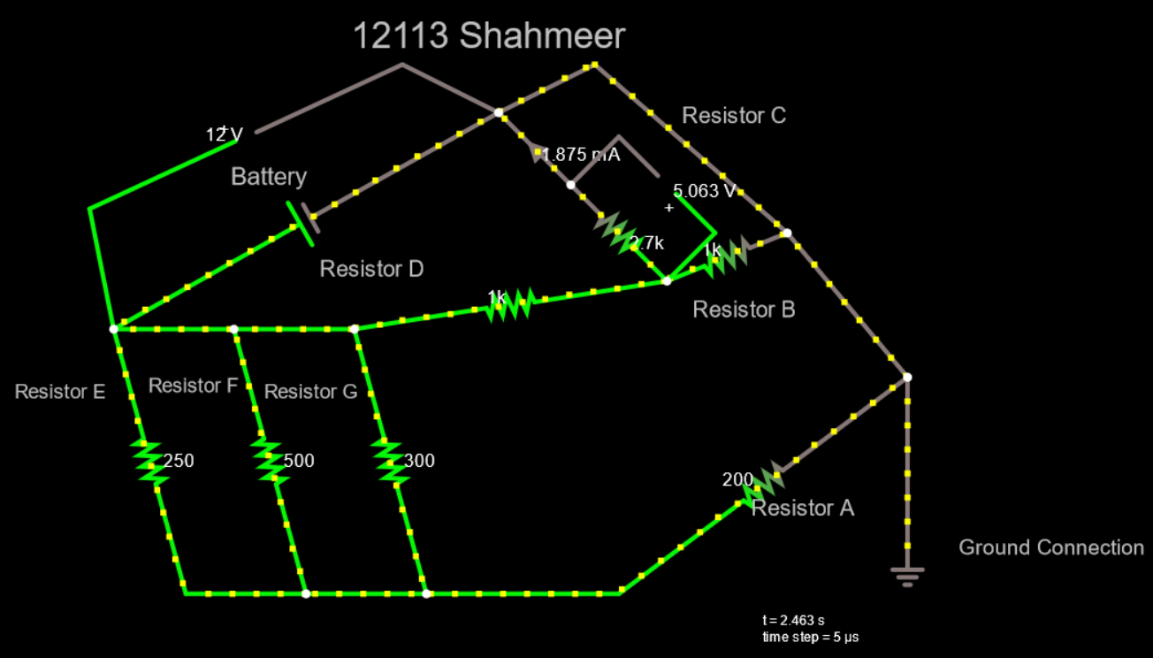

* ***It’s Link:***

<https://tinyurl.com/yjachgr7>

1. Current, Voltage across Resistor D:

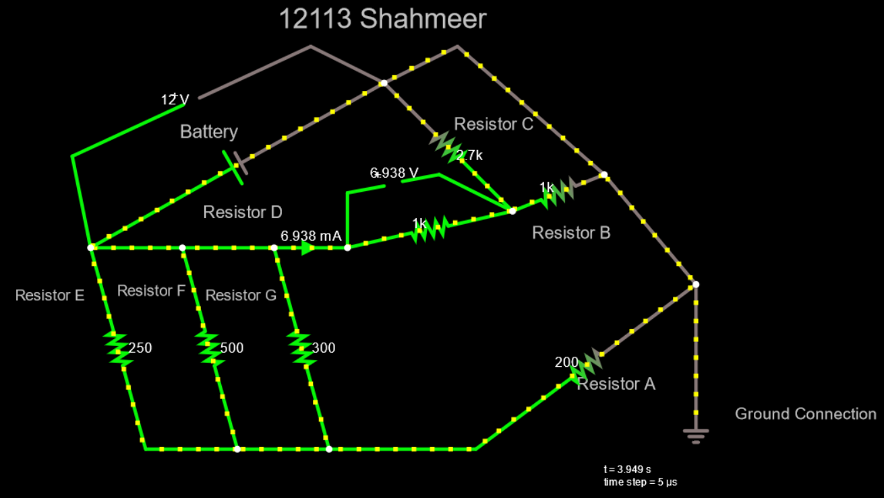

* ***It’s Link:***

<https://tinyurl.com/ygz5hnja>

1. Current, Voltage across Resistor E:

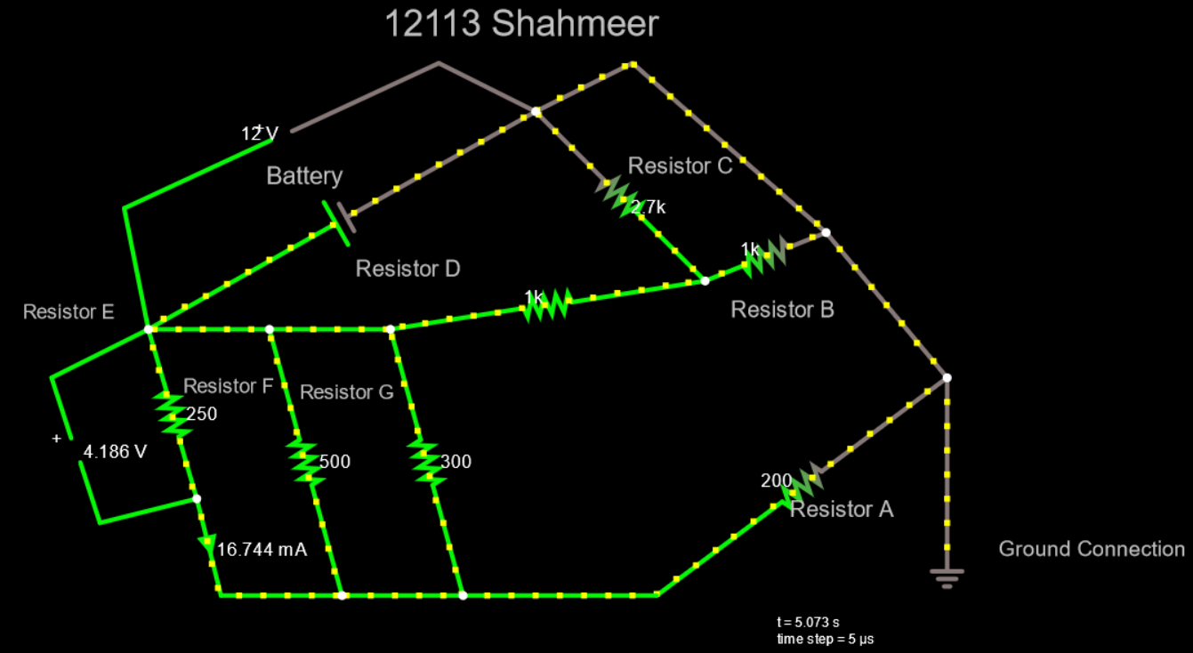

* ***It’s Link:***

<https://tinyurl.com/yjty4qr2>

1. Current, Voltage across Resistor F:

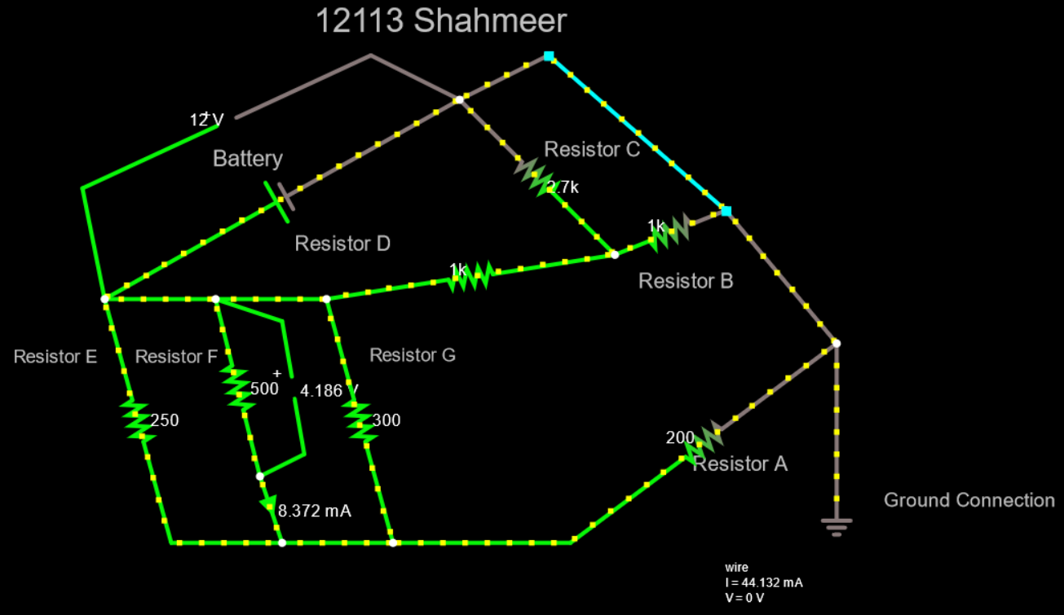

* ***It’s Link:***

<https://tinyurl.com/yep65eeu>

1. Current, Voltage across Resistor G:

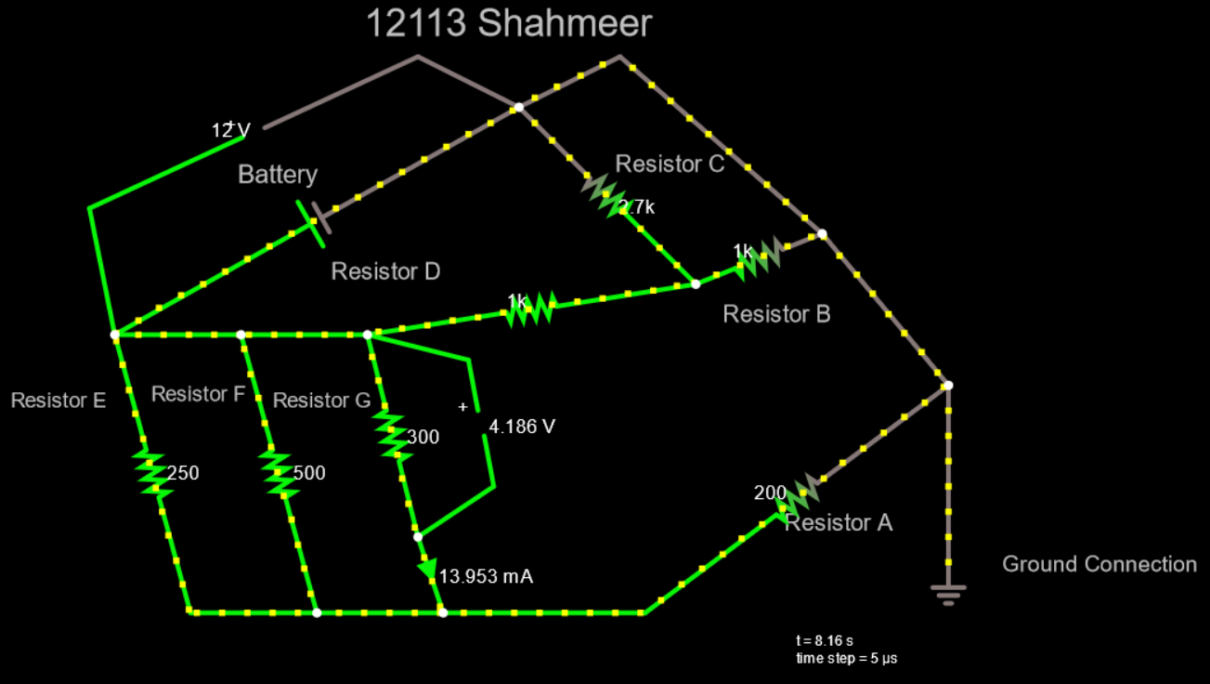

* ***It’s Link:***

<https://tinyurl.com/yjed3djr>

* All Circuits (Sequence Wise):

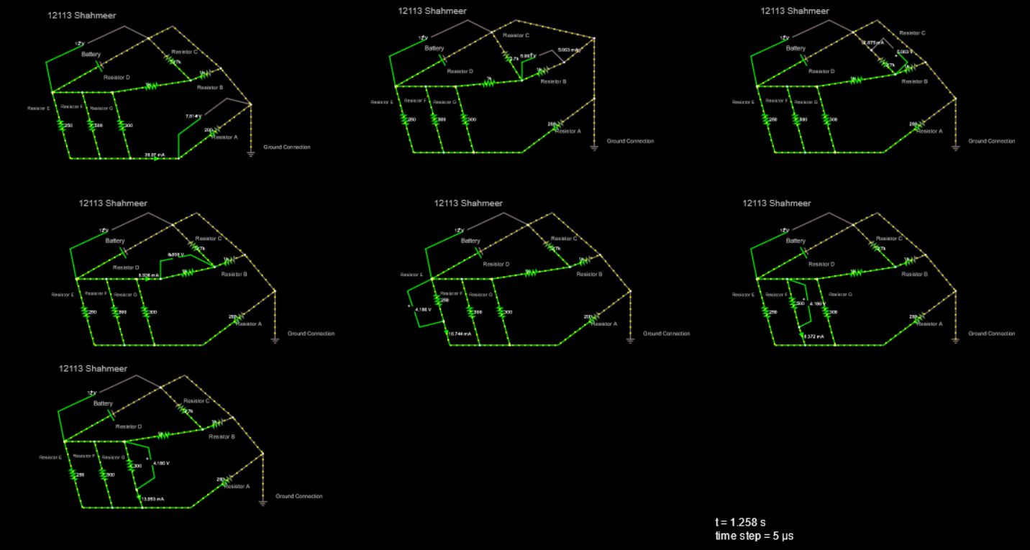

* ***Link:***

<https://tinyurl.com/yk4o5ajq>

* ***Observations/Calculations:***
* Now as we know the voltage and Current across each Component/Resistor so calculating power across each one of them:
* For Component A:

R = 200

V = 7.814

I = 0.039070 amp

P = VI

P = (7.814) x (0.039070)

P = 0.305292 w

* For Component B:

R = 1000

V = 5.063

I = 0.005063 amp

P = VI

P = (5.063) x (0.005063)

P = 0.025633 w

* For Component C:

R = 2700

V = 5.063

I = 0.001875 amp

P = VI

P = (5.064) x (0.001875)

P = 0.009495 w

* For Component D:

R = 1000

V = 6.938

I = 0.006938 amp

P = VI

P = (6.938) x (0.006938)

P = 0.048135 w

* For Component E:

R = 250

V = 4.186

I = 0.016744 amp

P = VI

P = (4.186) x (0.016744)

P = 0.070090 w

* For Component F:

R = 500

V = 4.186

I = 0.008372 amp

P = VI

P = (4.186) x (0.008372)

P = 0.035045 w

* For Component G:

R = 300

V = 4.186

I = 0.013953 amp

P = VI

P = (4.186) x (0.013953)

P = 0.058407 w

***TABLE***

|  |  |  |  |  |
| --- | --- | --- | --- | --- |
| **COMPONENTS** | **RESISTANCES** | **VOLTAGES** | **CURRENTS** | **POWERS** |
| **A** | 200 | 7.814 | 0.039070 | 0.305292 |
| **B** | 1000 | 5.063 | 0.005063 | 0.025633 |
| **C** | 2700 | 5.063 | 0.001875 | 0.009495 |
| **D** | 1000 | 6.938 | 0.006938 | 0.048135 |
| **E** | 250 | 4.186 | 0.016744 | 0.070090 |
| **F** | 500 | 4.186 | 0.008372 | 0.035045 |
| **G** | 300 | 4.186 | 0.013953 | 0.058407 |

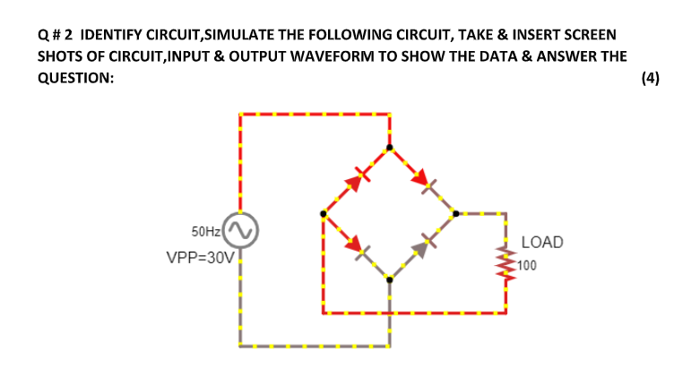

***Full Wave Rectifier Circuit***

***Screenshots:***

* Circuit:

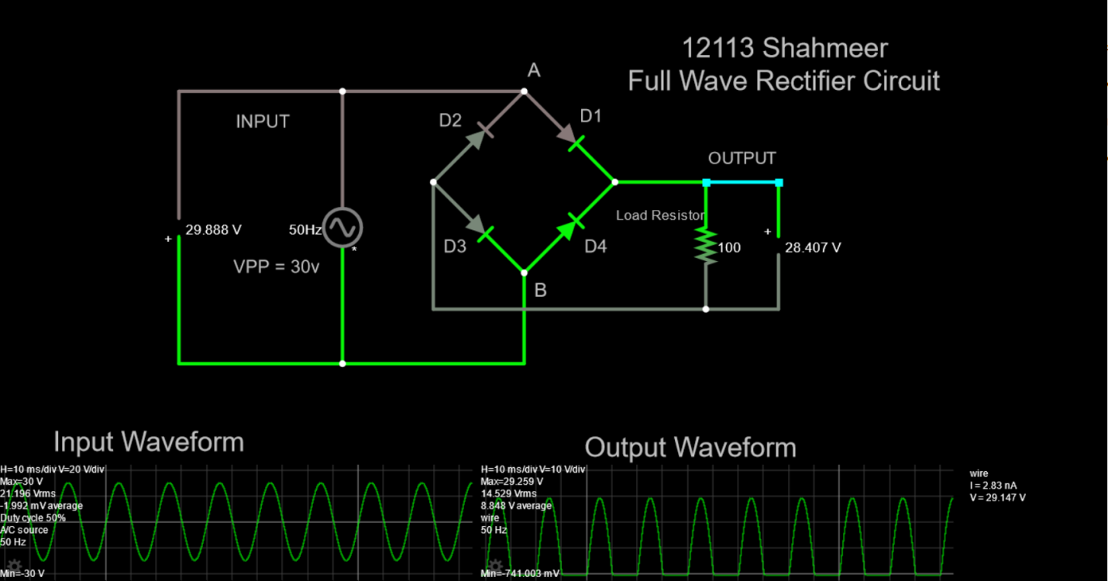

* Circuit with RMS Voltage, Output Peak Voltage and Ammeter Connected:

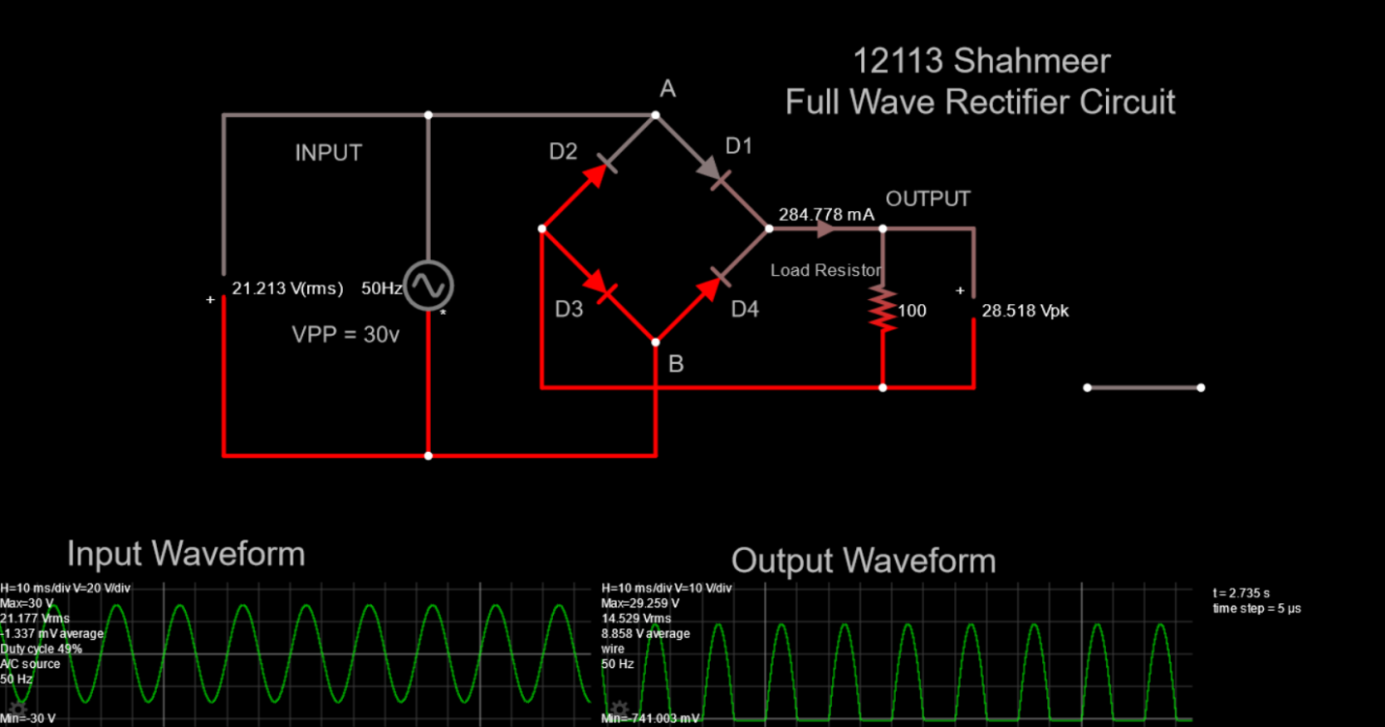

1. VPin= Vac(Vrms) / 0.707 OR Vpp / 2 =  **15 v**
2. Vrms =Vac= **10.6065 v**
3. Vrms (avg) =Vac (avg)= **10.6065 v**
4. V avg = Idc * R = 0.28477 * 100 = **14.238 v**
5. VP out = VPin – 1.4 =  **14.3 v**
6. Vrms(out) = VPout =  **14.6295 v**

***Link:***

<https://tinyurl.com/ye77tgob>

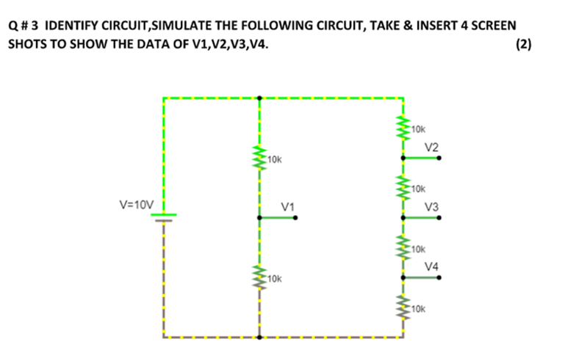

***Voltage Divider Circuit***

***Screenshots:***

* Circuit:

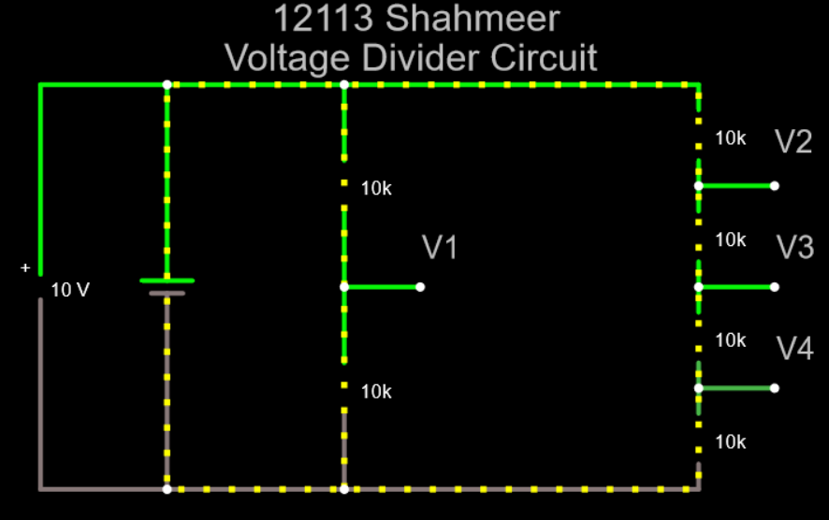

* Voltage on Points V1, V2, V3, V4 in “View in New Scope”:

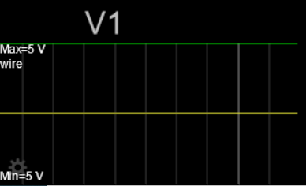

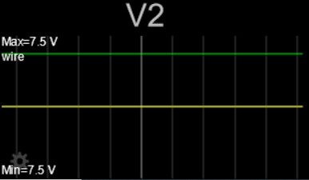

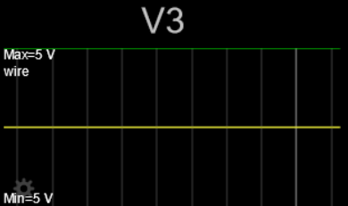

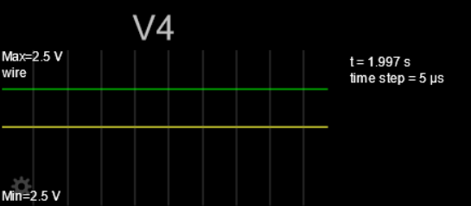

* Whole Circuit:

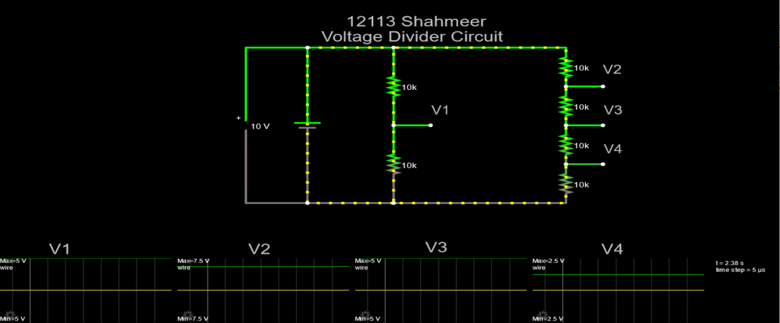

V1=______5______ V

V2=______7.5______V

V3=______5______V

V4=______2.5______V

* ***Link:***

<https://tinyurl.com/yznaoemt>